1. Fix the bugs in below snippet

<html lang="en">

<head>

<title>Document

<body>

guvi

</title>

</head>

<div>

Lorem ipsum dolor sit amet consectetur adipisicing elit.

<div>

<div>

Guvi Geek Network

</div>

</body>

</html>

Answer:<body> tag was inside the <title>tag element. So the output will be

Document<body>guvi.Generally <body>tag should be outside after the Head tag.

2).Try the below one

<html lang="en">

<head>

<title>Document

<body>

guvi

</head>

<div>

Lorem ipsum dolor sit amet consectetur adipisicing elit.

<div>

<div>

Guvi Geek Network

</div>

</body>

</html>

Answer: <title> was not closed. It’ll be error.

3)Create an element that helps you to open the [https://google.com](https://google.com/) in separate new tab.

Answer: <!DOCTYPE html>

<html lang="en">

<head>

    <meta charset="UTF-8">

    <meta name="viewport" content="width=device-width, initial-scale=1.0">

    <title>Document</title>

</head>

<body>

    <a href="https://google.com" target="_blank">google</a>

</body>

</html>

4)Use certain HTML elements to display the following in a HTML page.

<!DOCTYPE html>

<html lang="en">

<head>

    <meta charset="UTF-8">

    <meta name="viewport" content="width=device-width, initial-scale=1.0">

    <title>Document</title>

</head>

<body>

    <ul>

        <li>Prograamming Language</li>

    </ul>

    <ul style = "list-style-type:circle;">

    <li>Javascript</li>

    </ul>

    <ol type="a">

        <li>Angular</li>

        <li>React</li>

        <li>Vue.js</li>

    </ol>

    <ul style = "list-style-type:circle;">

        <li>Python</li>

    </ul>

    <ol type="a">

        <li>Django Framework</li>

        <li>Flask Framework</li>

    </ol>

    <ul style = "list-style-type:circle;">

        <li>Java</li>

    </ul>

    <ol type="a">

        <li>Spring</li>

        <li>Maven</li>

        <li>Hibernate</li>

    </ol>

    <ul>

        <li>Database</li>

        </ul>

        <ul style = "list-style-type:circle;">

        <li>MySQL</li>

        <li>MongoDB</li>

        <li>Cansandra</li>

    </ul>

</body>

</html>

Output:

* Prograamming Language
* Javascript

1. Angular
2. React
3. Vue.js

* Python

1. Django Framework
2. Flask Framework

* Java

1. Spring
2. Maven
3. Hibernate

* Database
* MySQL
* MongoDB
* Cansandra

5)In the form, add two radio buttons with grouping them for employee type(Salaried and own business)

<!DOCTYPE html>

<html lang="en">

<head>

    <meta charset="UTF-8">

    <meta name="viewport" content="width=device-width, initial-scale=1.0">

    <title>Document</title>

</head>

<body>

    <form>

        <fieldset>

            <legend>Employee type</legend>

        <input type="radio" name="Employee type" id="Salaried" value="Salaried">

        <label for="Salaried">Salaried</label><br/>

        <input type="radio" name="Employee type" id="own business" value="own business">

        <label for="own business">own business</label><br/>

        </fieldset>

    </form>

</body>

</html>

OUTPUT:\



6) Write HTML input tags snippet to show default values for all Form elements.

<!DOCTYPE html>

<html lang="en">

<head>

    <meta charset="UTF-8">

    <meta name="viewport" content="width=device-width, initial-scale=1.0">

    <title>Document</title>

</head>

<body>

    <form>

        <label for="Username">Username</label><br/>

        <input type="text" name="yourname" id="Username" value = "guvi"/><br/>

        <label for="password">password</label><br/>

        <input type="text" name="pass" id="password" value="gvi2021"/><br/>

        <input type="radio" id = "male" name = "gender" value = "male" checked/>

        <label for="male">male</label><br/>

        <input type="radio" id = "female" name = "gender" value="female">

        <label for="female">Female</label><br/>

        <input type="checkbox" id="agree" checked>

        <label for="agree"> yes i agree</label>

        <input type="checkbox" id="don't agree" >

        <label for="don't agree">no i don't</label>

        <input type="submit" value="submit"/><br/>

        <input type="reset" value = "reset"/> <br/>

        <input type="button" value="button"/><br/>

        <button type="button">Click here!!</button>

         <label for="fruits">choose a fruit you like</label>

        <select name="fruits" id="fruits" >

            <optgroup label = "citrix fruits">

        <option value="apple">apple</option>

        <option value="orange">orange</option>

        </optgroup>

        <optgroup label="vitd fruits">

        <option value="guava">guava</option>

        </optgroup>

        </select>

        <input type="submit" value ="submit">

    </form>

    </form>

</body>

</html>

OUTPUT:

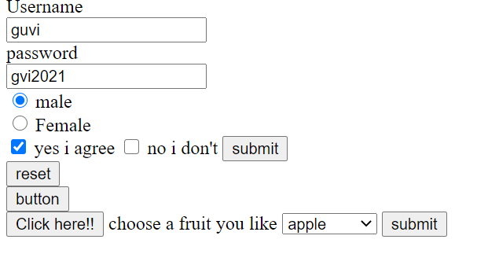

7)Use the table tag to design given image [Click here](https://www.bapugraphics.com/assets/img/port_upload_dir/table-4.jpg).

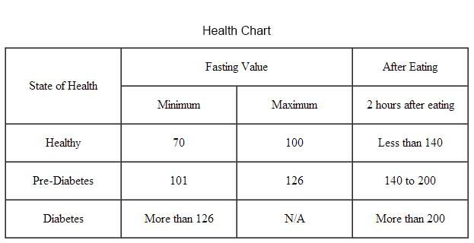

Answer)

<!DOCTYPE html>

<html lang="en">

<head>

    <meta charset="UTF-8">

    <meta name="viewport" content="width=device-width, initial-scale=1.0">

    <title>Document</title>

    <style>

        table, th, td {

            border:1px solid black;

            border-collapse: collapse;

        }

    </style>

</head>

<body>

<table>

    <table style="width:70%">

      <p style="text-align:center;">Health Chart</p>

    <tr>

    <th rowspan ="2">State Of Health</th>

    <th colspan ="2">Fasting Value</th>

    <th>After Eating</th>

    </tr>

    <tr>

        <th>Minimum</th>

        <th>Maximum</th>

        <th>2 hours after eating</th>

    </tr>

    <tr>

        <th>Healthy</th>

        <td style="text-align: center;">70</td>

        <td style="text-align: center;">100</td>

        <td style="text-align: center;">Less than 140</td>

    </tr>

    <tr>

        <th>Pre-Diabetes</th>

        <td style="text-align: center;">101</td>

        <td style="text-align: center;">126</td>

        <td style="text-align: center;">140 to 200</td>

    </tr>

    <tr>

        <th>Diabetes</th>

        <td style="text-align: center;">More than 126</td>

        <td style="text-align: center;">N/A</td>

        <td style="text-align: center;">More than 200</td>

    </tr>

</table>

</body>

</html>

OUTPUT:

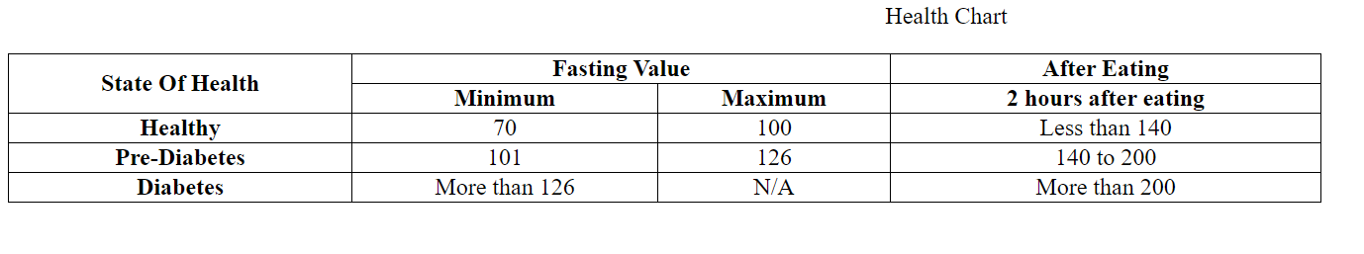8) Design a contact us form with all fields as required.

<!DOCTYPE html>

<html lang="en">

<head>

    <meta charset="UTF-8">

    <meta name="viewport" content="width=device-width, initial-scale=1.0">

    <title>Document</title>

</head>

<body>

    <form action="contact.php" method="post">

        <label for = "name"> Your Name</label><br>

        <input type="text" name="cf_name" required><br>

        <label for="Your e-mail">Your e=mail</label><br>

        <input type="text" name="cf_email" required><br>

        <label for="Message">Message</label><br>

        <textarea name="cf_message" required></textarea><br/>

        <input type="submit" value="Submit">

        <input type="reset" value="Clear">

    </form>

</body>

</html>

OUTPUT:

Your Name  
  
Your e=mail  
  
Message  
  
 

9) Create an HTML page, which should contain all types of input elements.

<!DOCTYPE html>

<html lang="en">

<head>

    <meta charset="UTF-8">

    <meta name="viewport" content="width=device-width, initial-scale=1.0">

    <title>Document</title>

</head>

<body>

    <form>

  <label for="fname">First name:</label><br>

  <input type="text" id="fname" name="fname"><br>

  <label for="lname">Last name:</label><br>

  <input type="text" id="lname" name="lname"><br/>

  <label for="pwd">Password:</label><br>

  <input type="password" id="pwd" name="pwd"><br/>

  <label for="email">Enter your email:</label>

  <input type="email" id="email" name="email">

  <input type="radio" id="male" name="gender" value="male">

  <label for="male">Male</label><br>

  <input type="radio" id="female" name="gender" value="female">

  <label for="female">Female</label><br>

  <input type="checkbox" id="vehicle1" name="vehicle1" value="Bike">

  <label for="vehicle1"> I have a bike</label><br>

  <input type="checkbox" id="vehicle2" name="vehicle2" value="Car">

  <label for="vehicle2"> I have a car</label><br>

  <input type="button" onclick="alert('Hello World!')" value="Click Me!"><br/>

  <label for="favcolor">Select your favorite color:</label>

  <input type="color" id="favcolor" name="favcolor"><br/>

  <label for="birthday">Birthday:</label>

  <input type="date" id="birthday" name="birthday"><br/>

  <label for="datemax">Enter a date before 1980-01-01:</label>

  <input type="date" id="datemax" name="datemax" max="1979-12-31"><br><br>

  <label for="datemin">Enter a date after 2000-01-01:</label>

  <input type="date" id="datemin" name="datemin" min="2000-01-02"><br/>

  <label for="birthdaytime">Birthday (date and time):</label>

  <input type="datetime-local" id="birthdaytime" name="birthdaytime"><br/>

  <label for="myfile">Select a file:</label>

  <input type="file" id="myfile" name="myfile"><br/>

  <label for="bdaymonth">Birthday (month and year):</label>

  <input type="month" id="bdaymonth" name="bdaymonth"><br/>

  <label for="quantity">Quantity (between 1 and 5):</label>

  <input type="number" id="quantity" name="quantity" min="1" max="5"><br/>

  <label for="quantity">Quantity:</label>

  <input type="number" id="quantity" name="quantity" min="0" max="100" step="10" value="30"><br/>

  <label for="vol">Volume (between 0 and 50):</label>

  <input type="range" id="vol" name="vol" min="0" max="50"><br/>

  <label for="gsearch">Search Google:</label>

  <input type="search" id="gsearch" name="gsearch"><br/>

  <label for="phone">Enter your phone number:</label>

  <input type="tel" id="phone" name="phone" pattern="[0-9]{3}-[0-9]{2}-[0-9]{3}"><br/>

  <label for="appt">Select a time:</label>

  <input type="time" id="appt" name="appt"><br/>

  <label for="homepage">Add your homepage:</label>

  <input type="url" id="homepage" name="homepage"><br/>

  <label for="week">Select a week:</label>

  <input type="week" id="week" name="week"><br/>

  <input type="submit" value="Submit">

  <input type="reset">

</body>

</html>

OUTPUT:

